END OF YEAR REPORT-PFIZER
Brief Description
The health of every child remains a priority to parents and the nation as a whole. In the past years, several measures have been put in place to ensure that every child under five years of age gets immunized against the childhood killer diseases. Considering the fact that children are born every day, there is a need for constant interventions to ensure that all children in communities especially hard to reach ones, get immunized.
Due to the fact that low immunization still remains a public health issue, the Ghana Coalition of NGOs in Health with financial support from Pfizer, a pharmaceutical company in the United States is implementing the Pfizer Immunization Support (PIS) project in six selected districts in the Volta region (a total of sixty communities) in order to get children immunized. The project aims at increasing immunization coverage in hard to reach and low immunization coverage communities by 90% by 2020 in the selected districts where the project is being implemented.

HFFG is implementing this project in five hard to reach and low immunization coverage communities each in the Kpando municipality and North Dayi district making it a total of ten (10).
Project Duration: 1 year (January 2018 to December 2018)
Project Donor: PFIZER
Project Objectives
- Increase demand and access to comprehensive and quality immunization in the project communities by 90% by 2020.
- Strengthen community participation to addressing barriers that inhibit access to childhood immunization services delivery to promote and increase demand for immunization at the community level through collaboration among community stakeholders.
- Promote the generation of an evidence base through the introduction of the use of community childhood immunization registers to improve data quality.
- To assess immunization coverage impact to advocate for communities involvement and support.
- Impact assessment, documentation and dissemination of learning outcomes for quality service delivery in the future
Number of communities: 10 (5 each in Kpando and North Dayi districts
Activities Implemented and Number of people reached
ACTIVITY | MALE | FEMALE | TOTAL
Number of Children Immunized | 701 | 720 | 1442
Number of Nurses Trained | 6 | 8 | 14
Number of Volunteers trained | 6 | 4 | 10
Number of Opinion leaders trained | 13 | 7 | 20
Household Sensitization |  |  | 4098
Community Durbar | 802 | 1231 | 2033
Committee Meeting Attendants | 76 | 47 | 123
Registration of children into Community Register | 230 | 261 | 491
Child Welfare Clinic Attendants (Parents and Care Givers) | 107 | 1159 | 1266

Challenges
- Organizing community durbars were a bit difficult because volunteers initially did the mobilization in some communities.
By the help of opinion leaders, some of the communities were mobilized for durbars because the opinion leaders are well respected in these communities and so people could not refuse to attend
- The raining season delayed the trip to the island communities due to fear of rain and wind.
By the help of the navigator and operator, the team finally agreed on a date after studying the trend of the weather.
Changes in the lives of beneficiaries
Through constant education by staff, nurses, volunteers and opinion leaders, myths and misconceptions about vaccines have now been cleared so parents and caregivers who held back earlier now allow their children to be immunized
Recommendations
- We would like to recommend that in future, funds should be released early for project implementation.
- Due to the positive impact this project has made towards child immunization in Project communities, we would like to recommend that in future, more communities should be added for others to adopt positive attitude towards child immunization.

Child Welfare Clinics
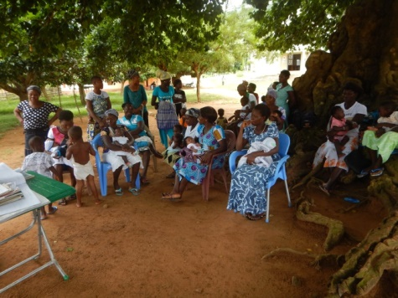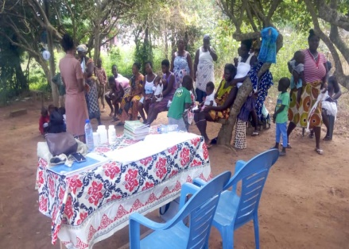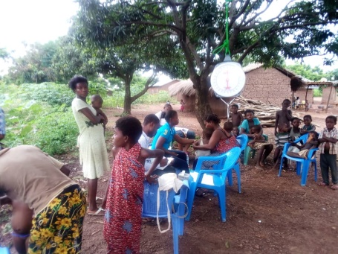
Camp Out Outreaches
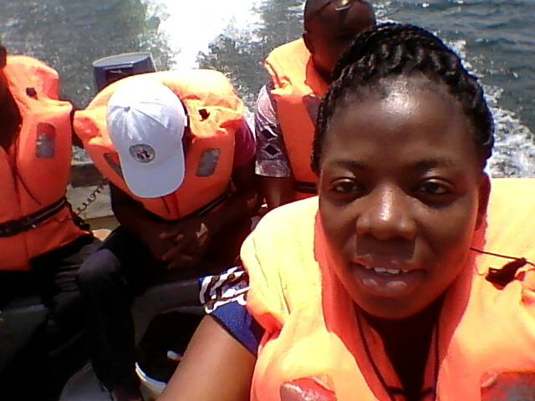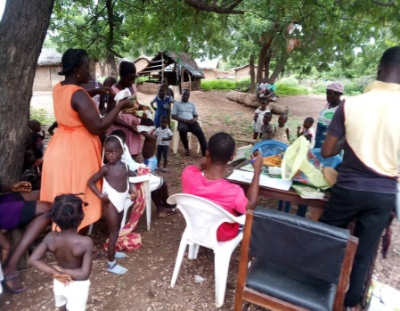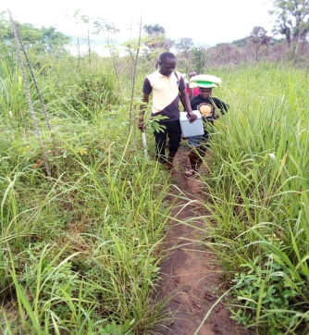

Community Durbar
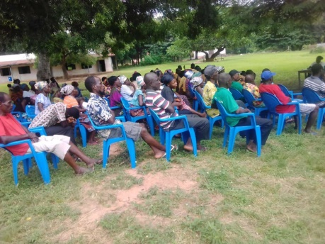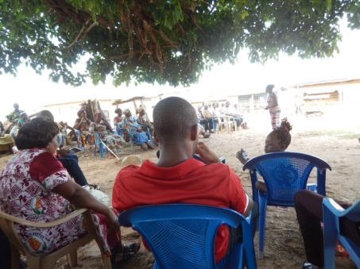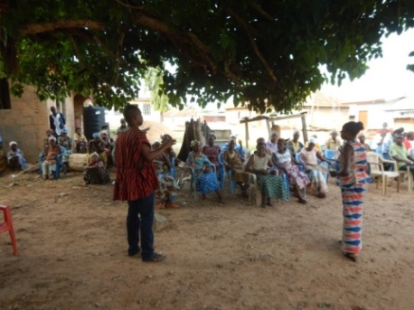
Community Health Committee Meetings
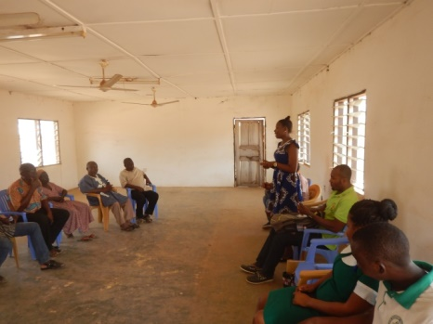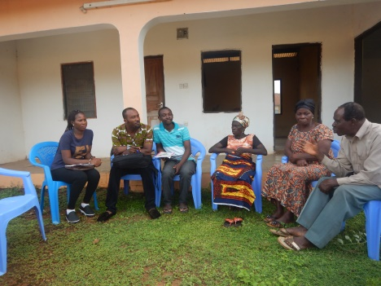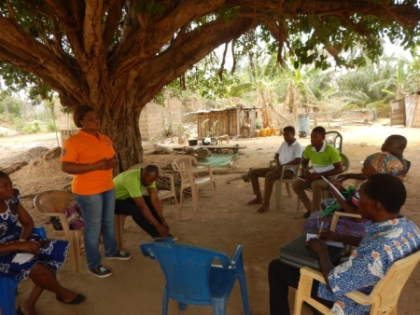
Joint Monitoring
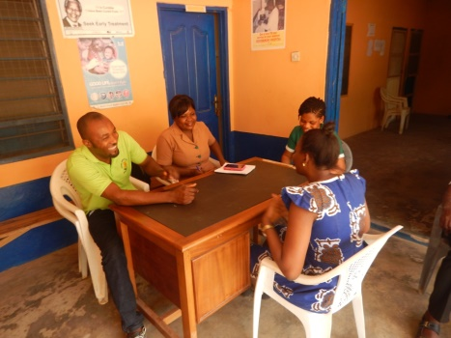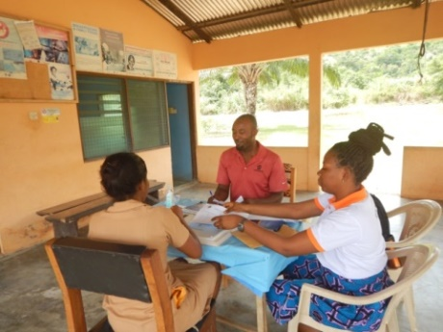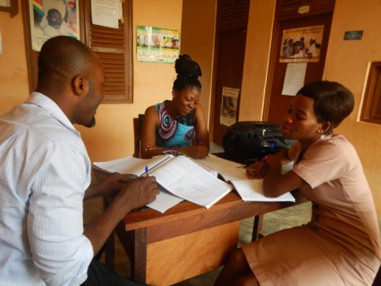
Procurement of Items for Satellite Sites
